Amar & Ermi:
BR_TM_01 - View and Search Tour Packages

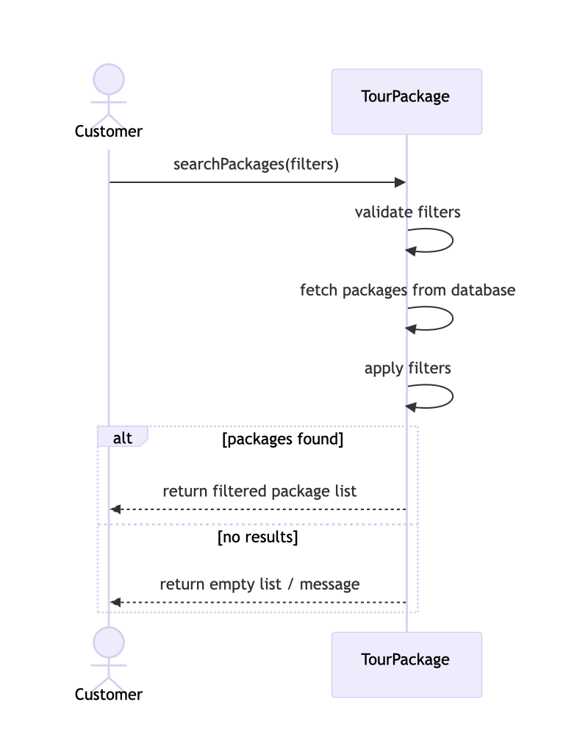

BR_TM_02 - Create Account and Login

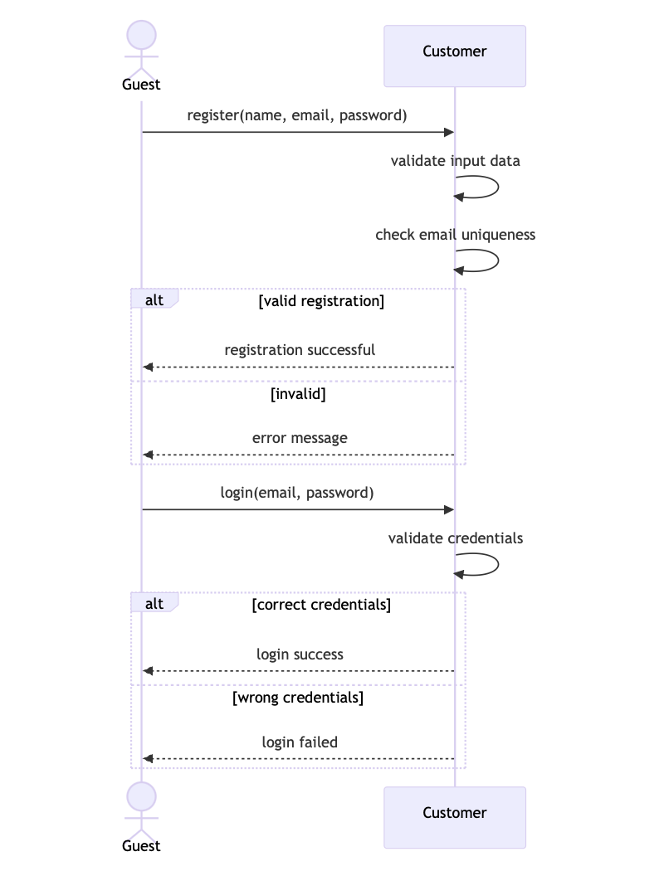

BR_TM_03 - Search and Filter Tour Packages

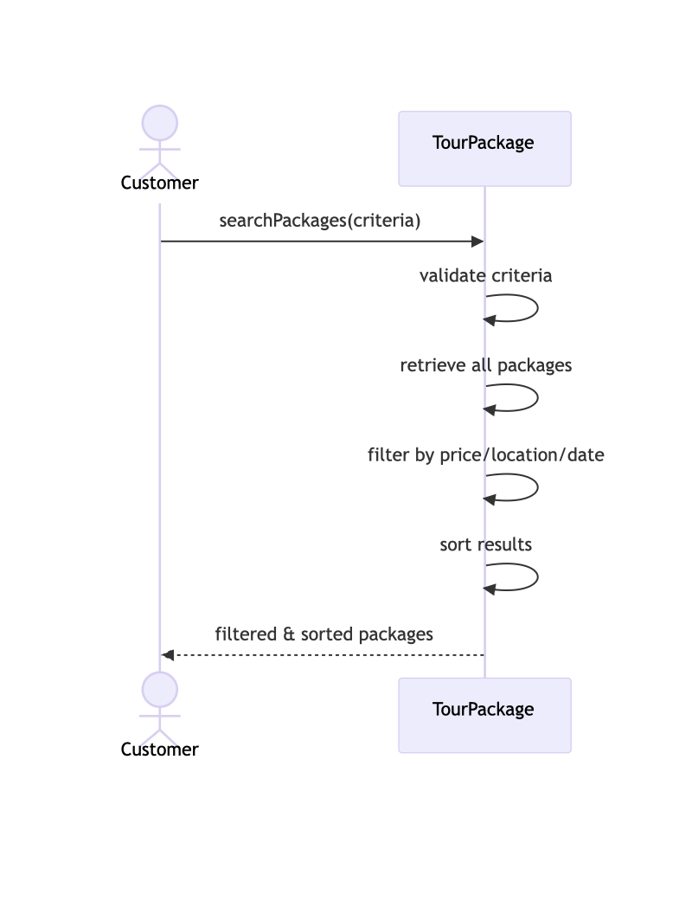

BR_TM_04 - View Tour Details
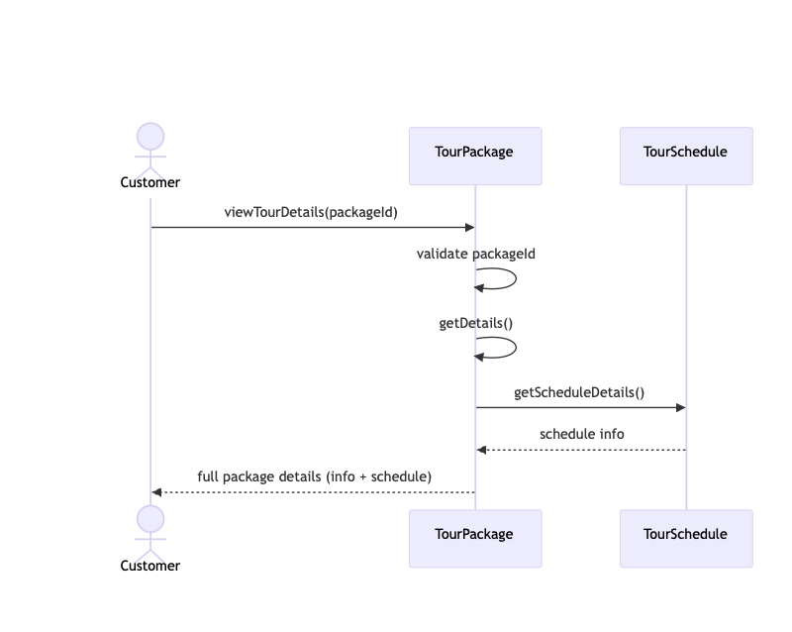
BR_TM_05 - Book Tour Package
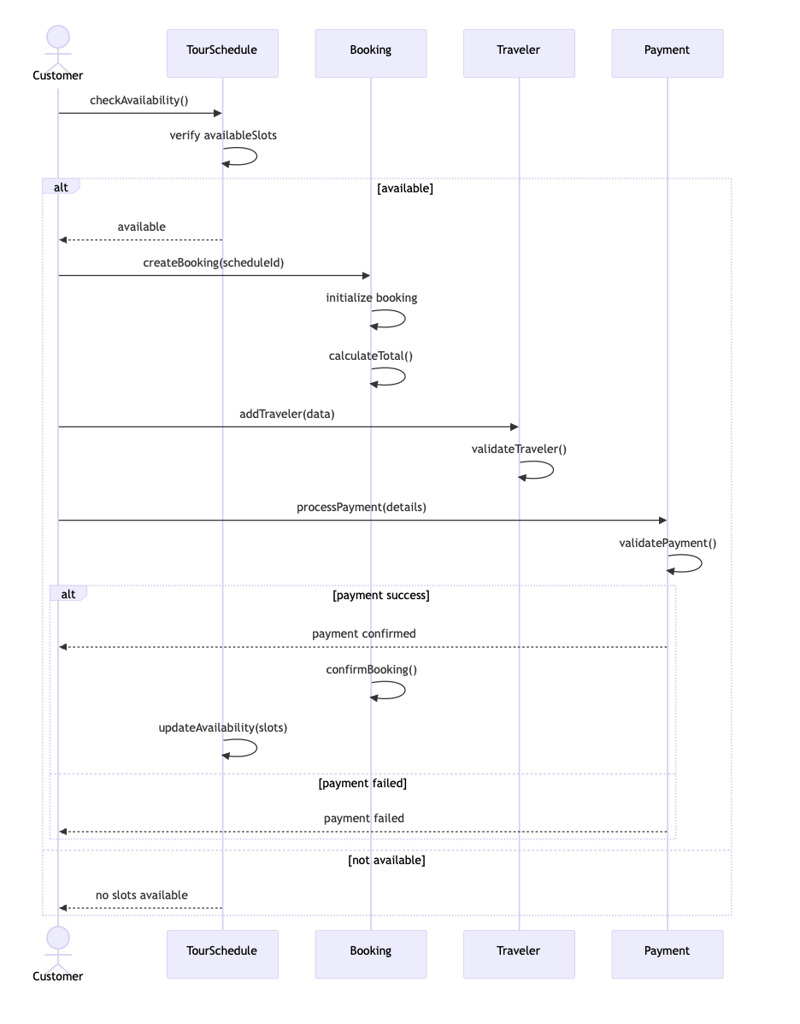
Alisa Dhima:
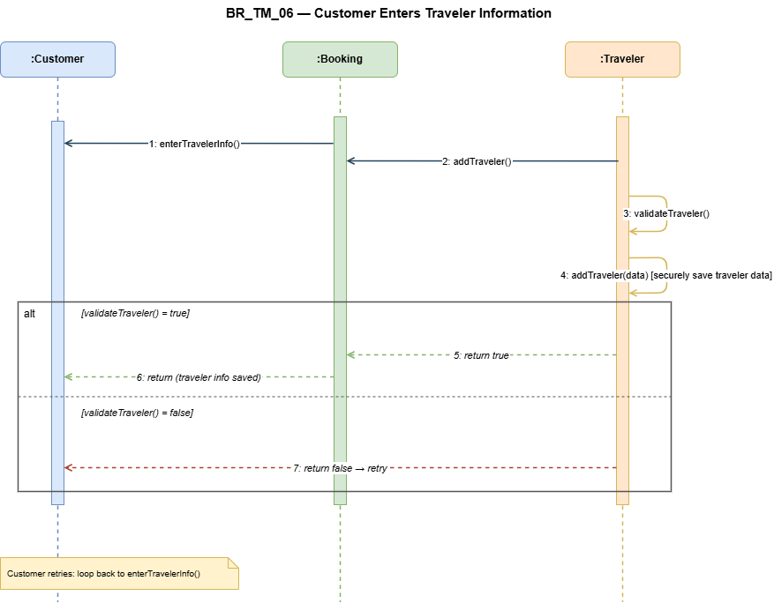

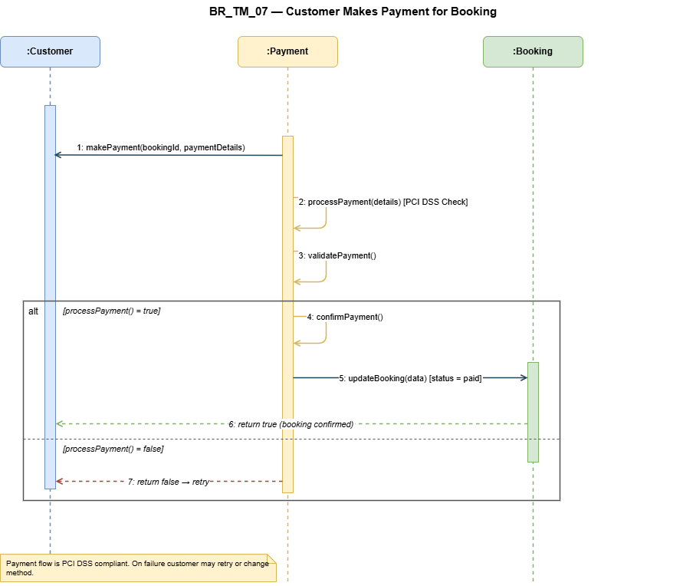

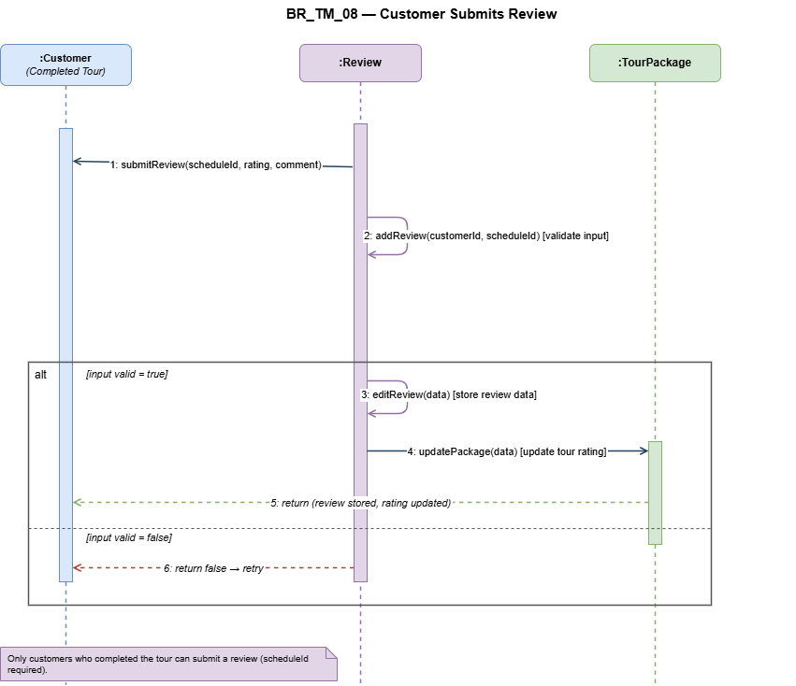

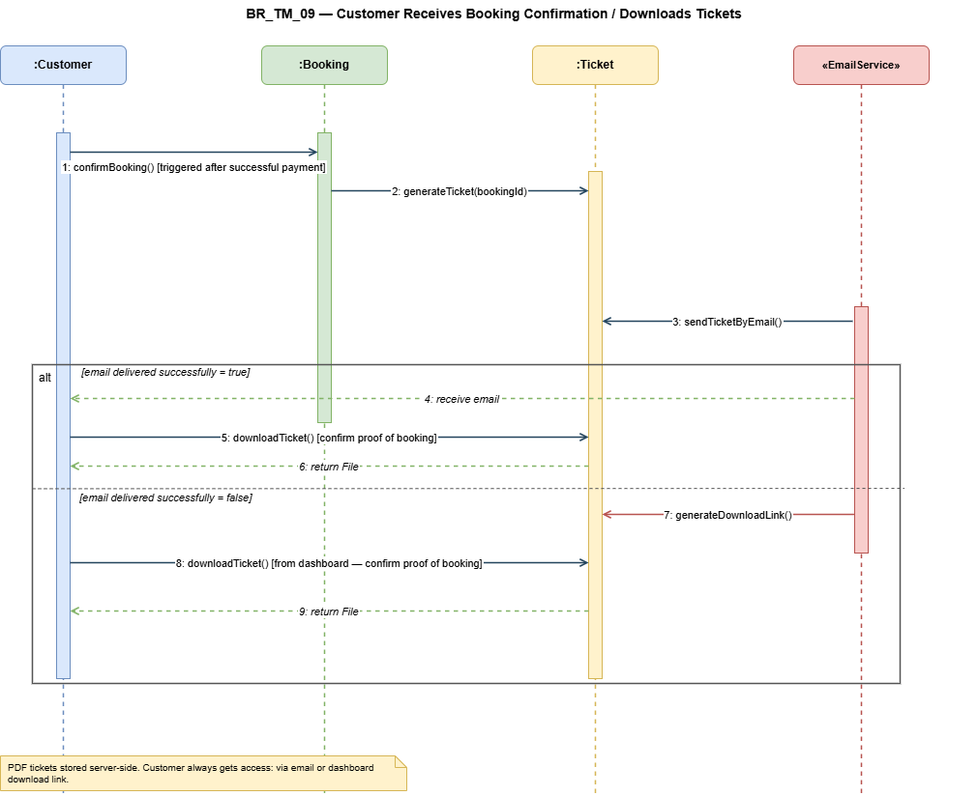
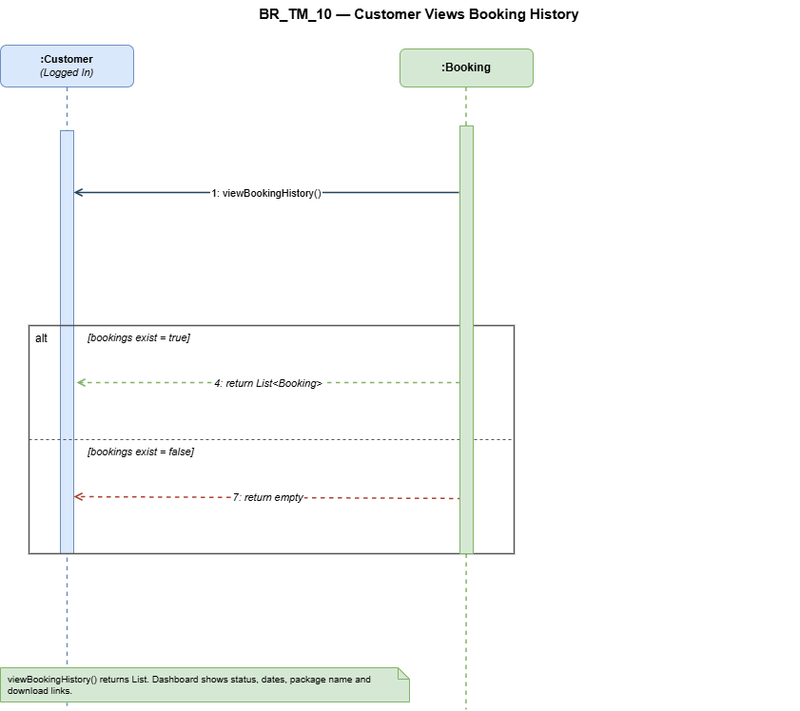

Amanda Stafasani:
BR_TM_11 — Customer cancels a booking
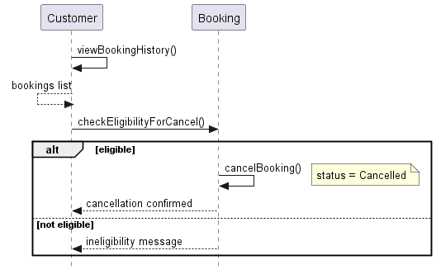
BR_TM_12 — Customer updates personal profile
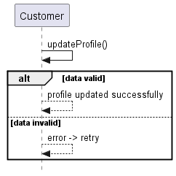

BR_TM_13 — Booking agent creates a booking for a customer
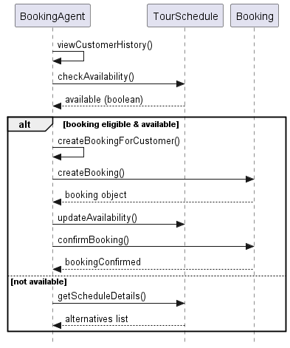

BR_TM_14 — Booking agent updates or cancels a reservation
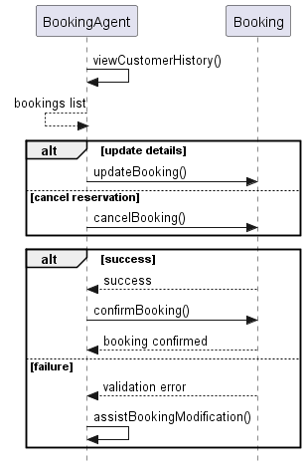
BR_TM_15 — Booking agent checks travel package availability
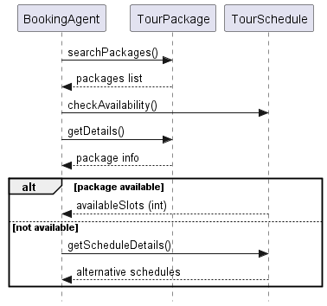

Lumturi Bedalli:
BR_TM_16 – Agent Views Customer Travel History
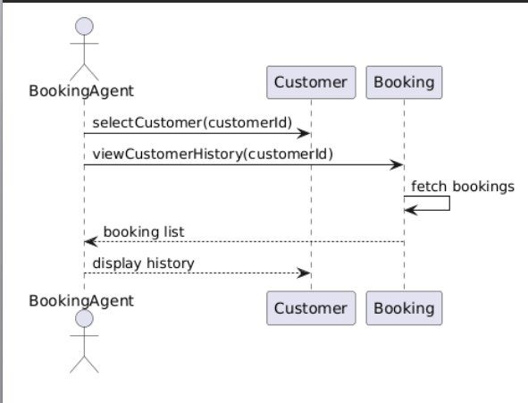

BR_TM_17 – Modify Existing Booking
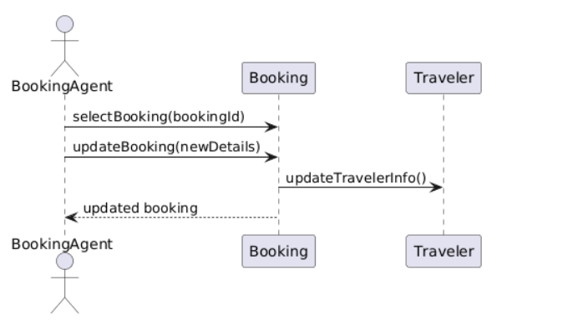
BR_TM_18 – Reply to Customer Reviews
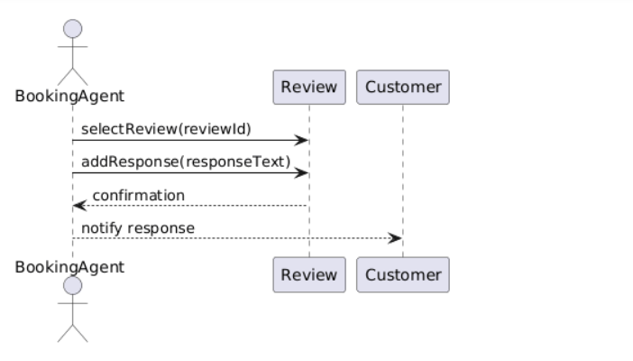

BR_TM_19 – Verify Customer Payments
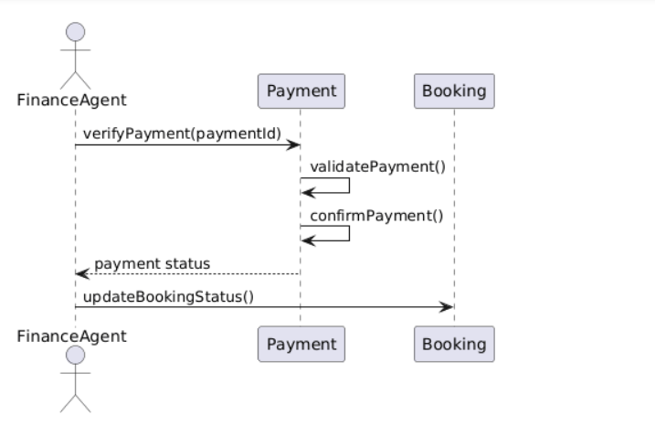
Henri Shehu:
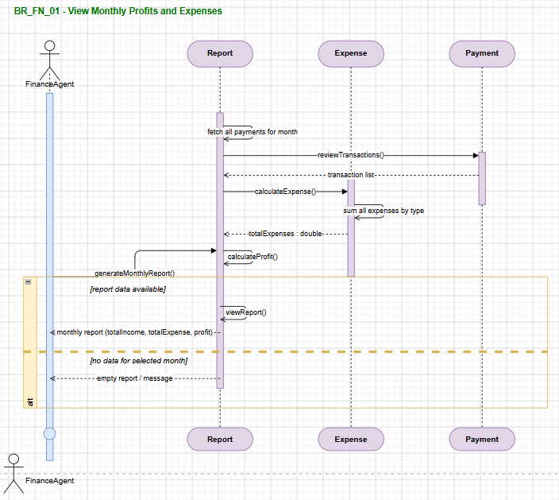

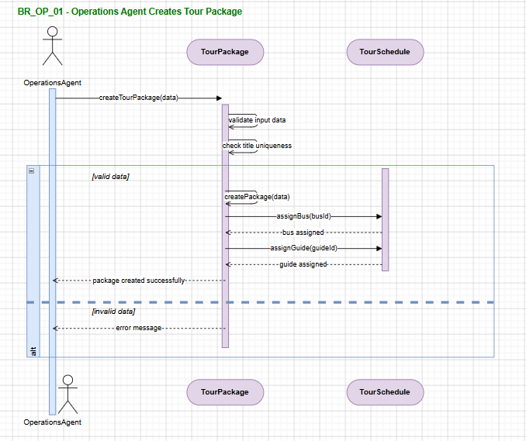
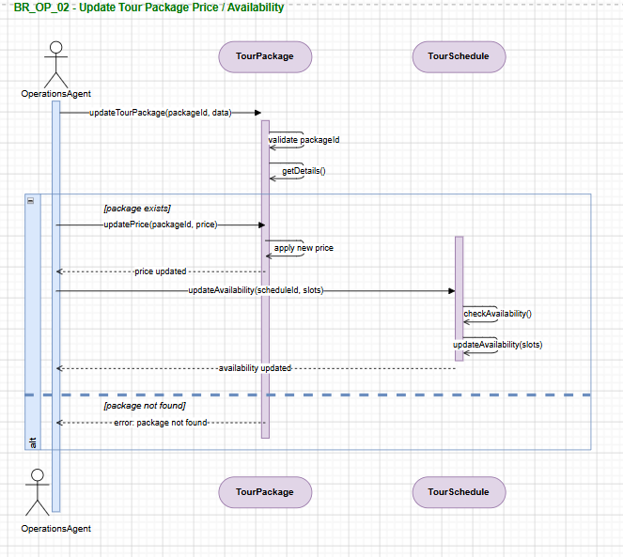

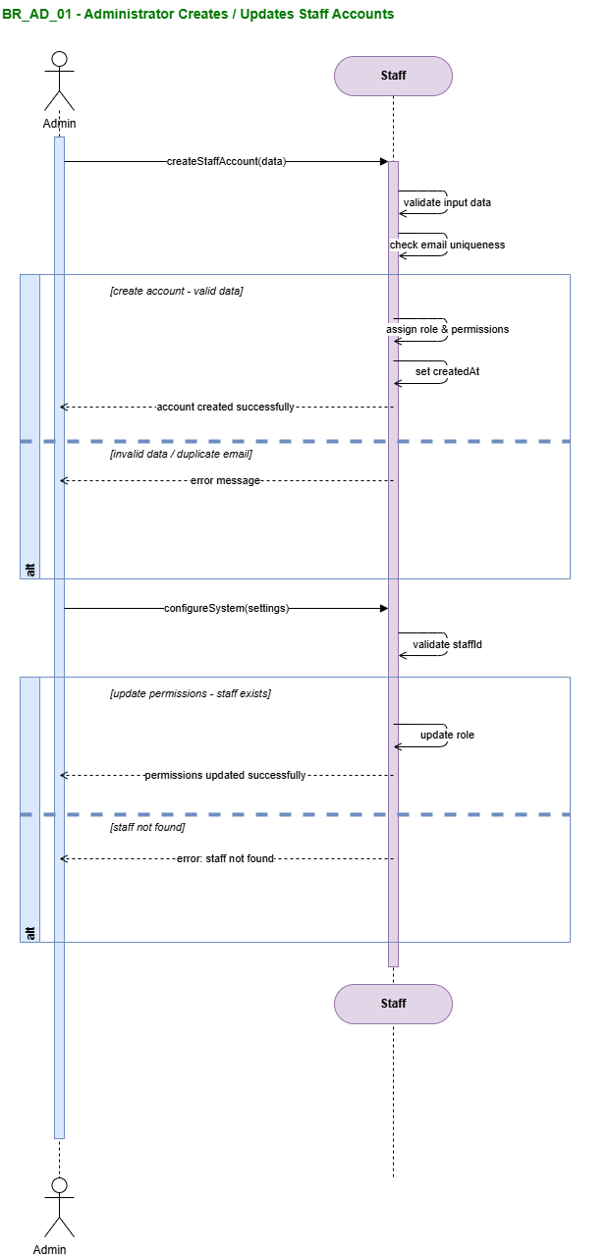
Enian Xhixha:
BR-TM-24 - Administrator deletes inactive staff accounts
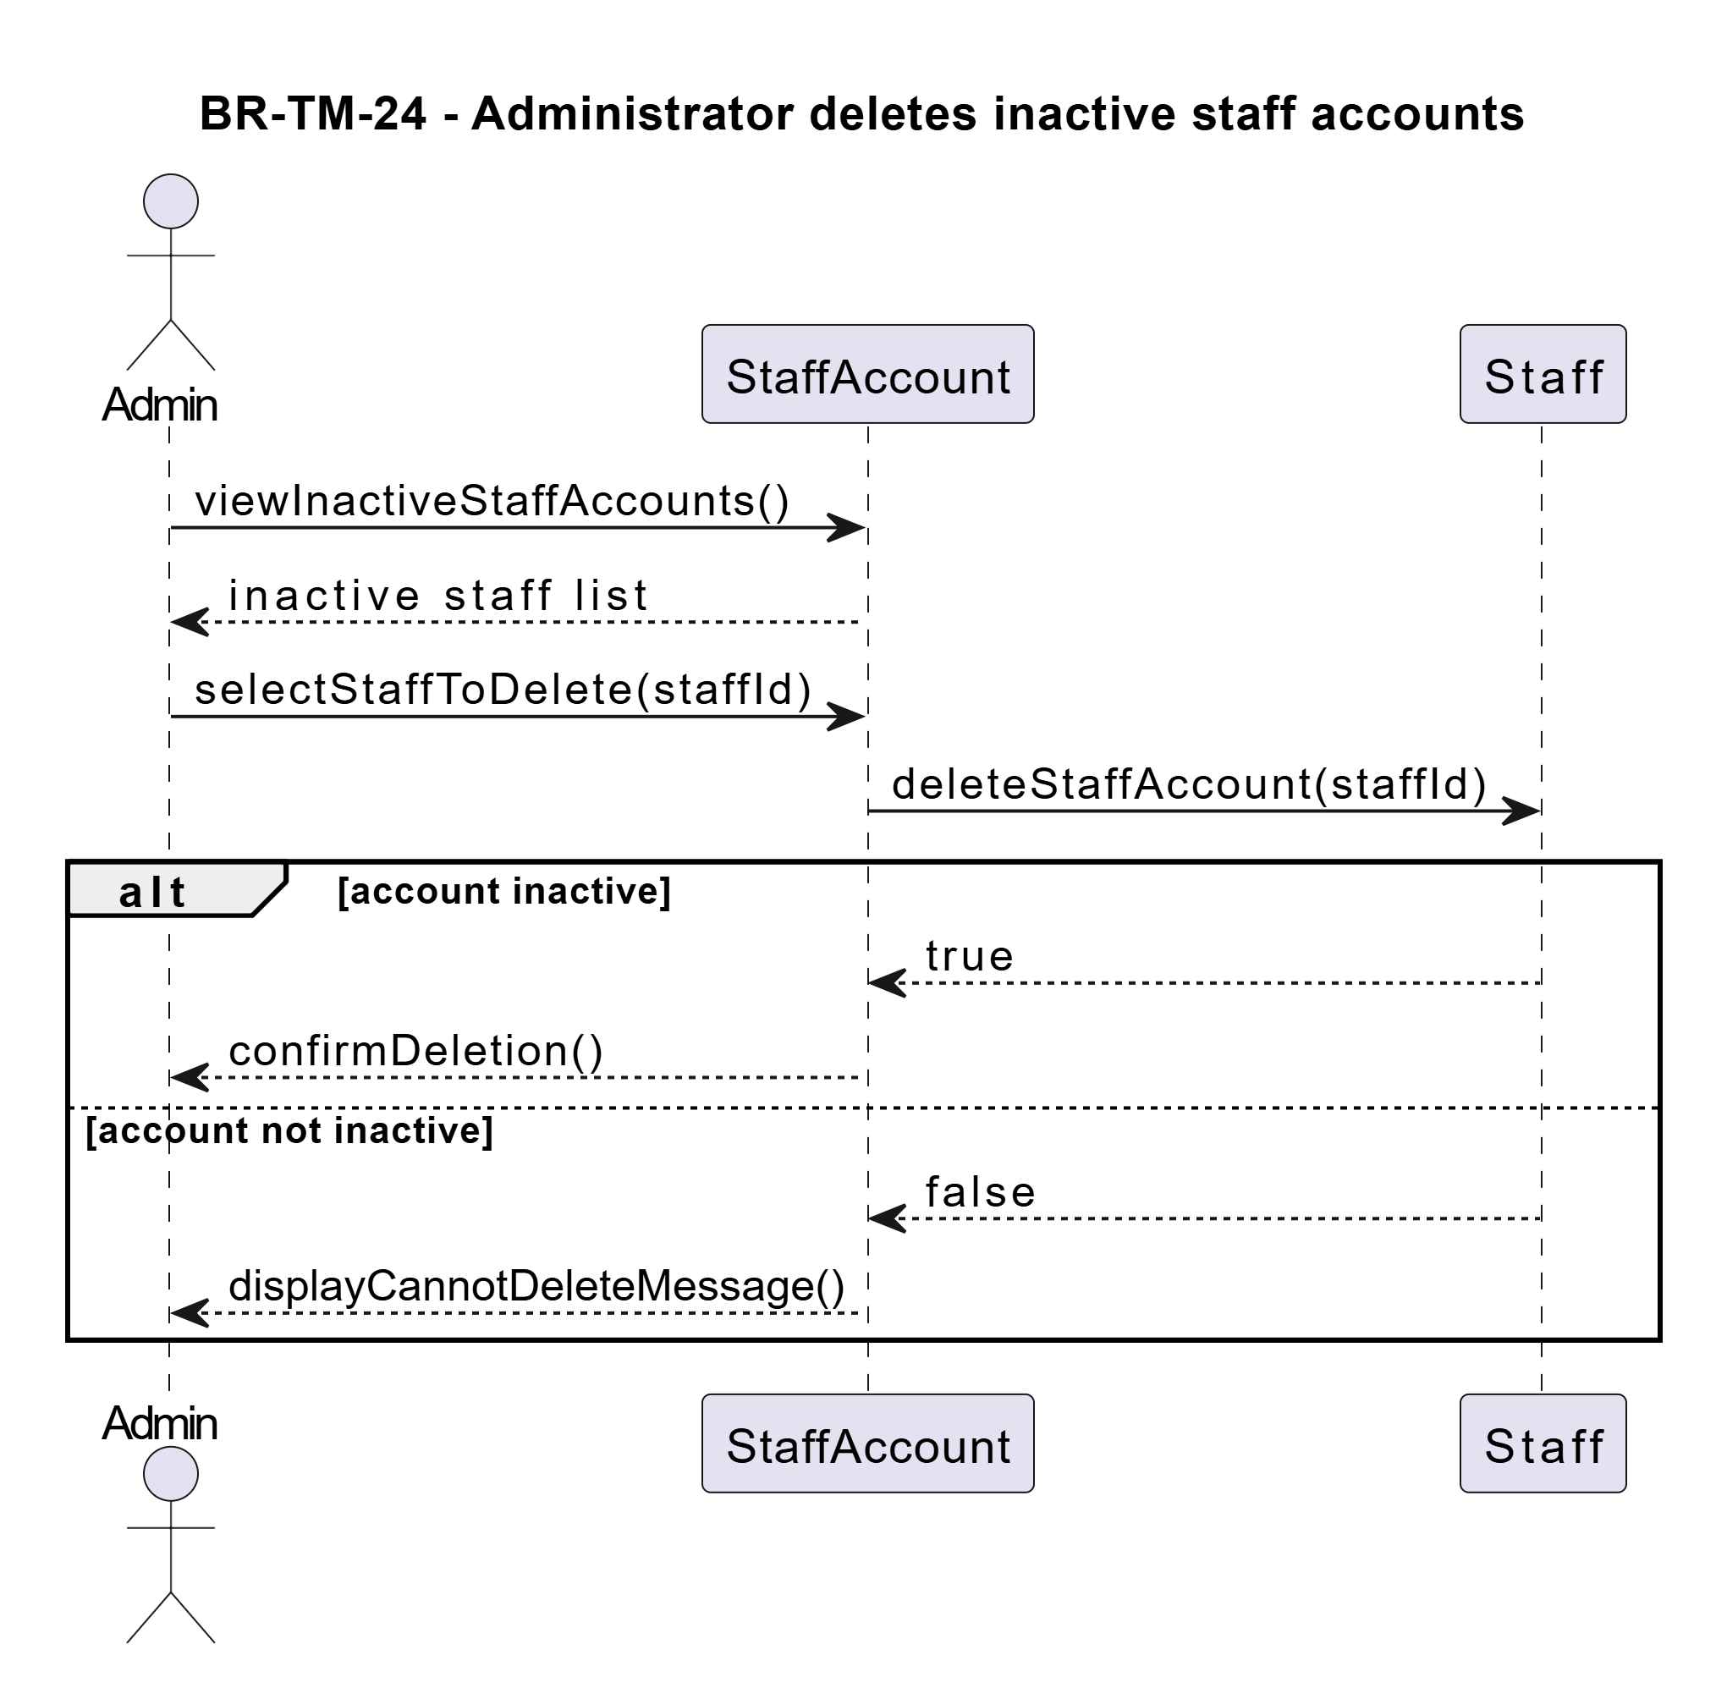
BR-TM-25 - Configuration of system settings
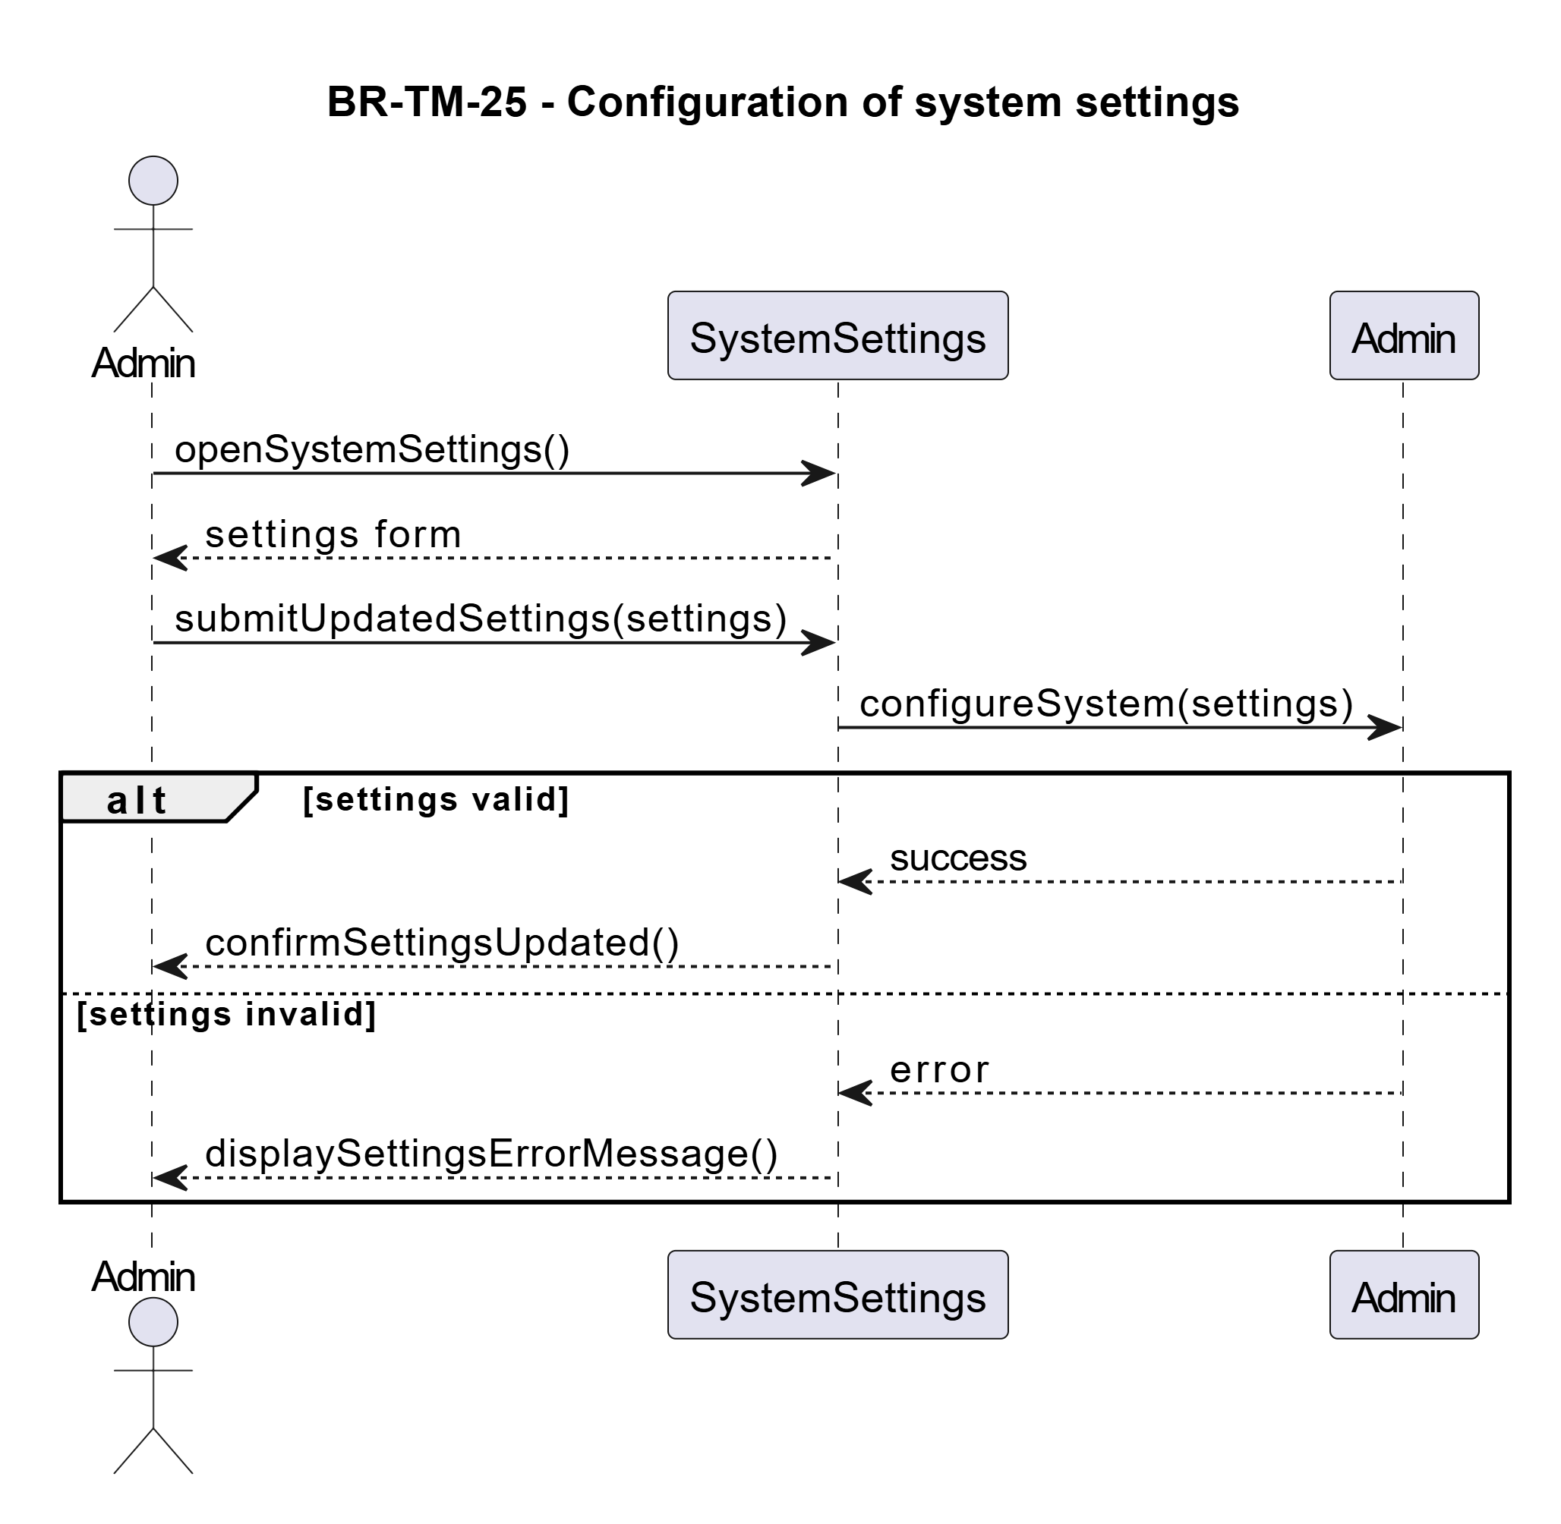
BR-TM-26: View sales reports
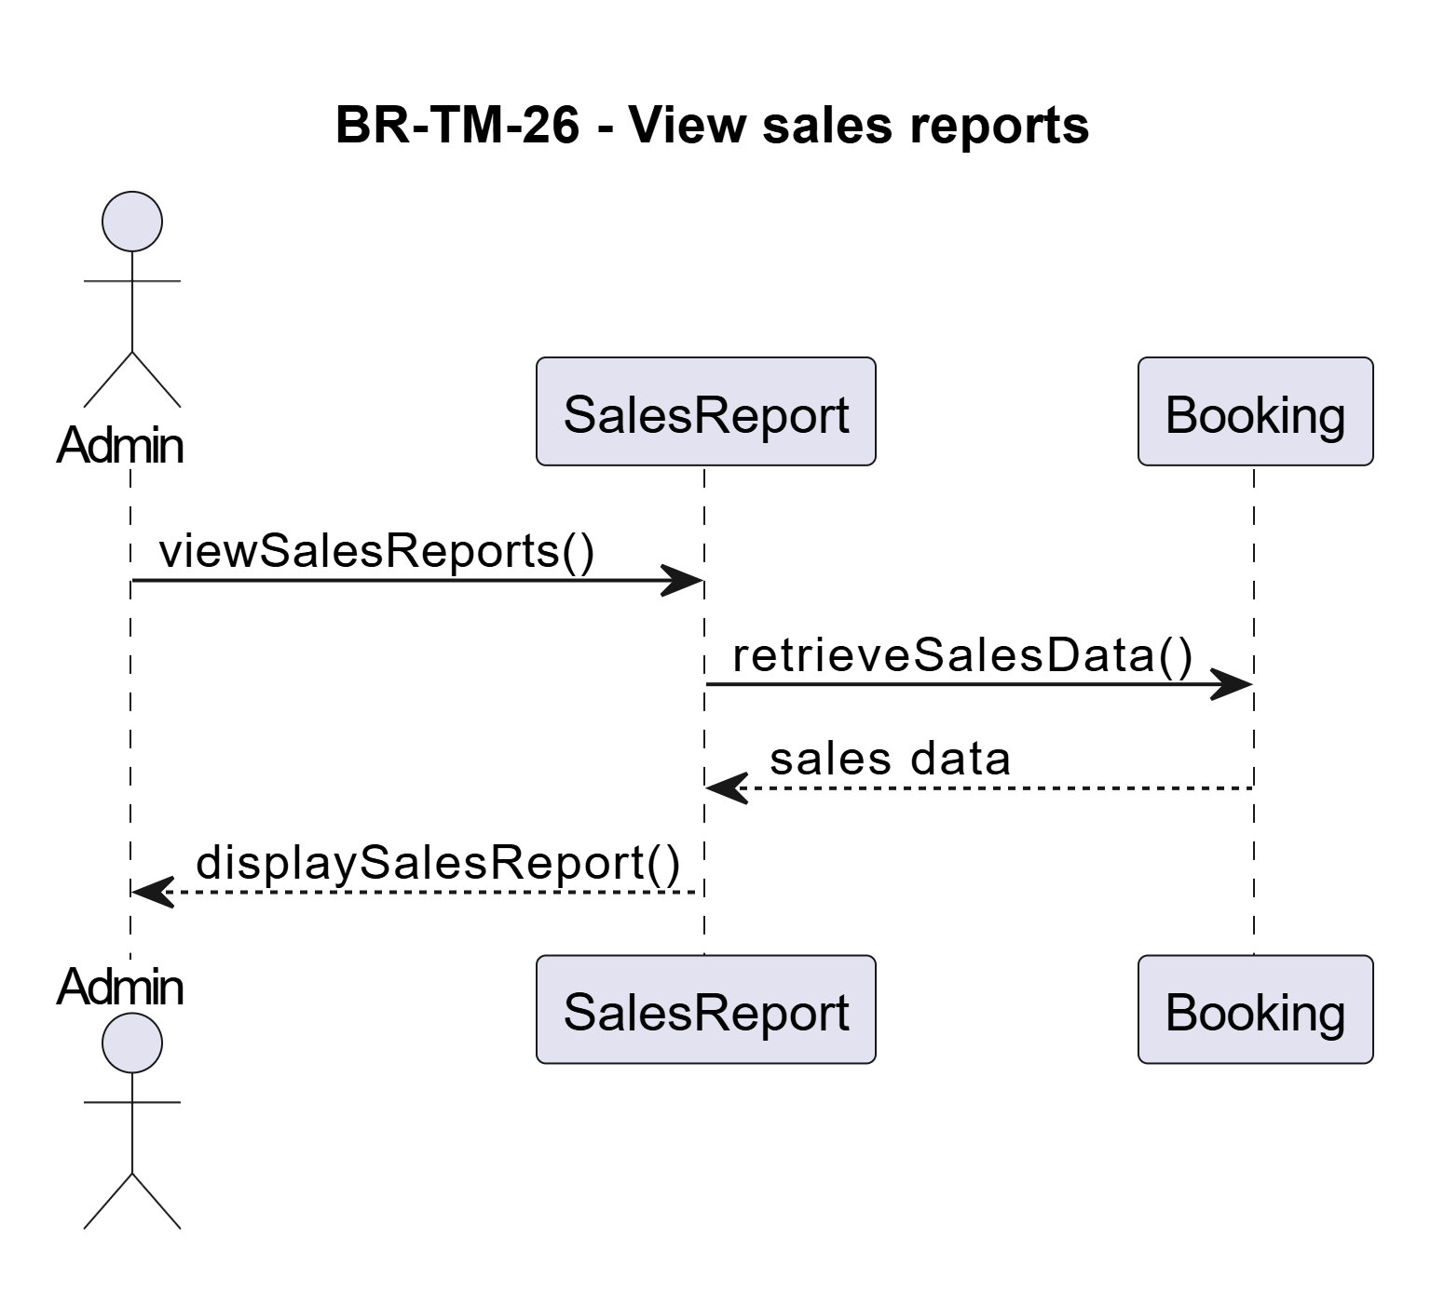
BR-TM-27: Recruit Bus Drivers
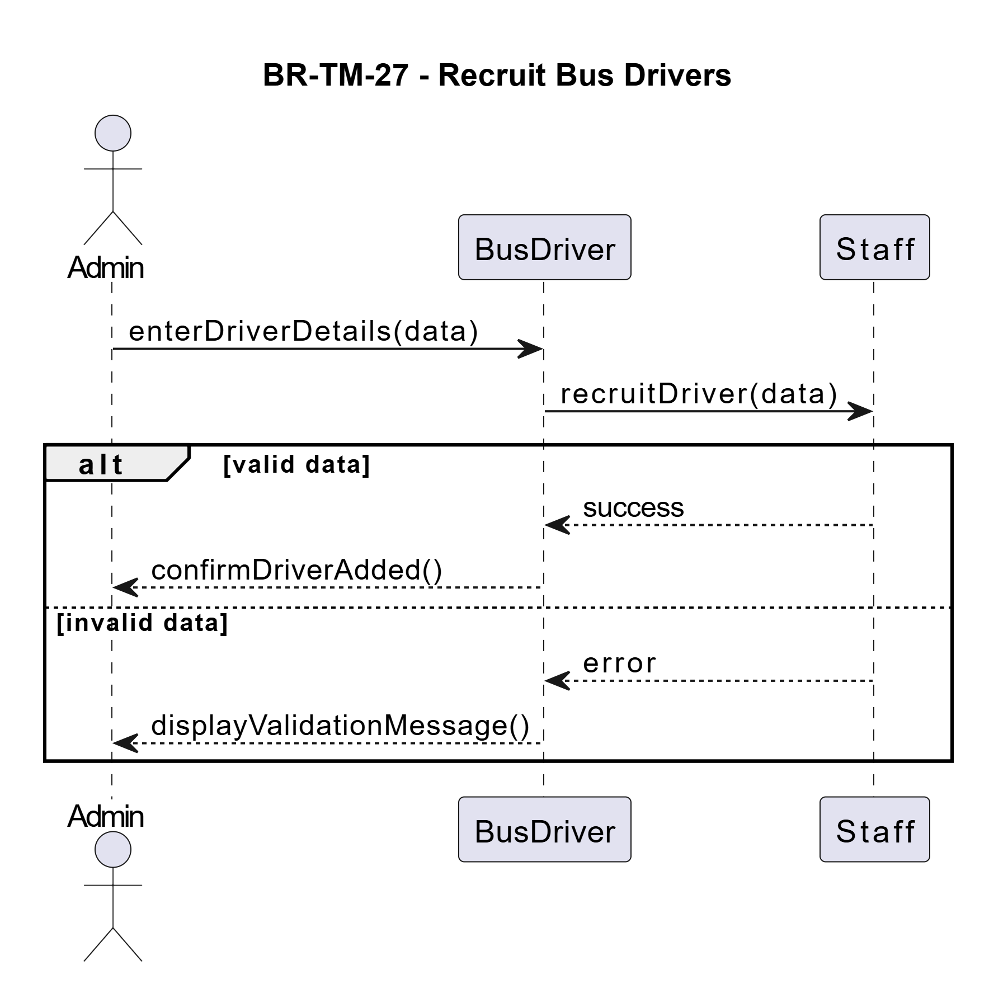
BR-TM-28: Assign Buses for Service

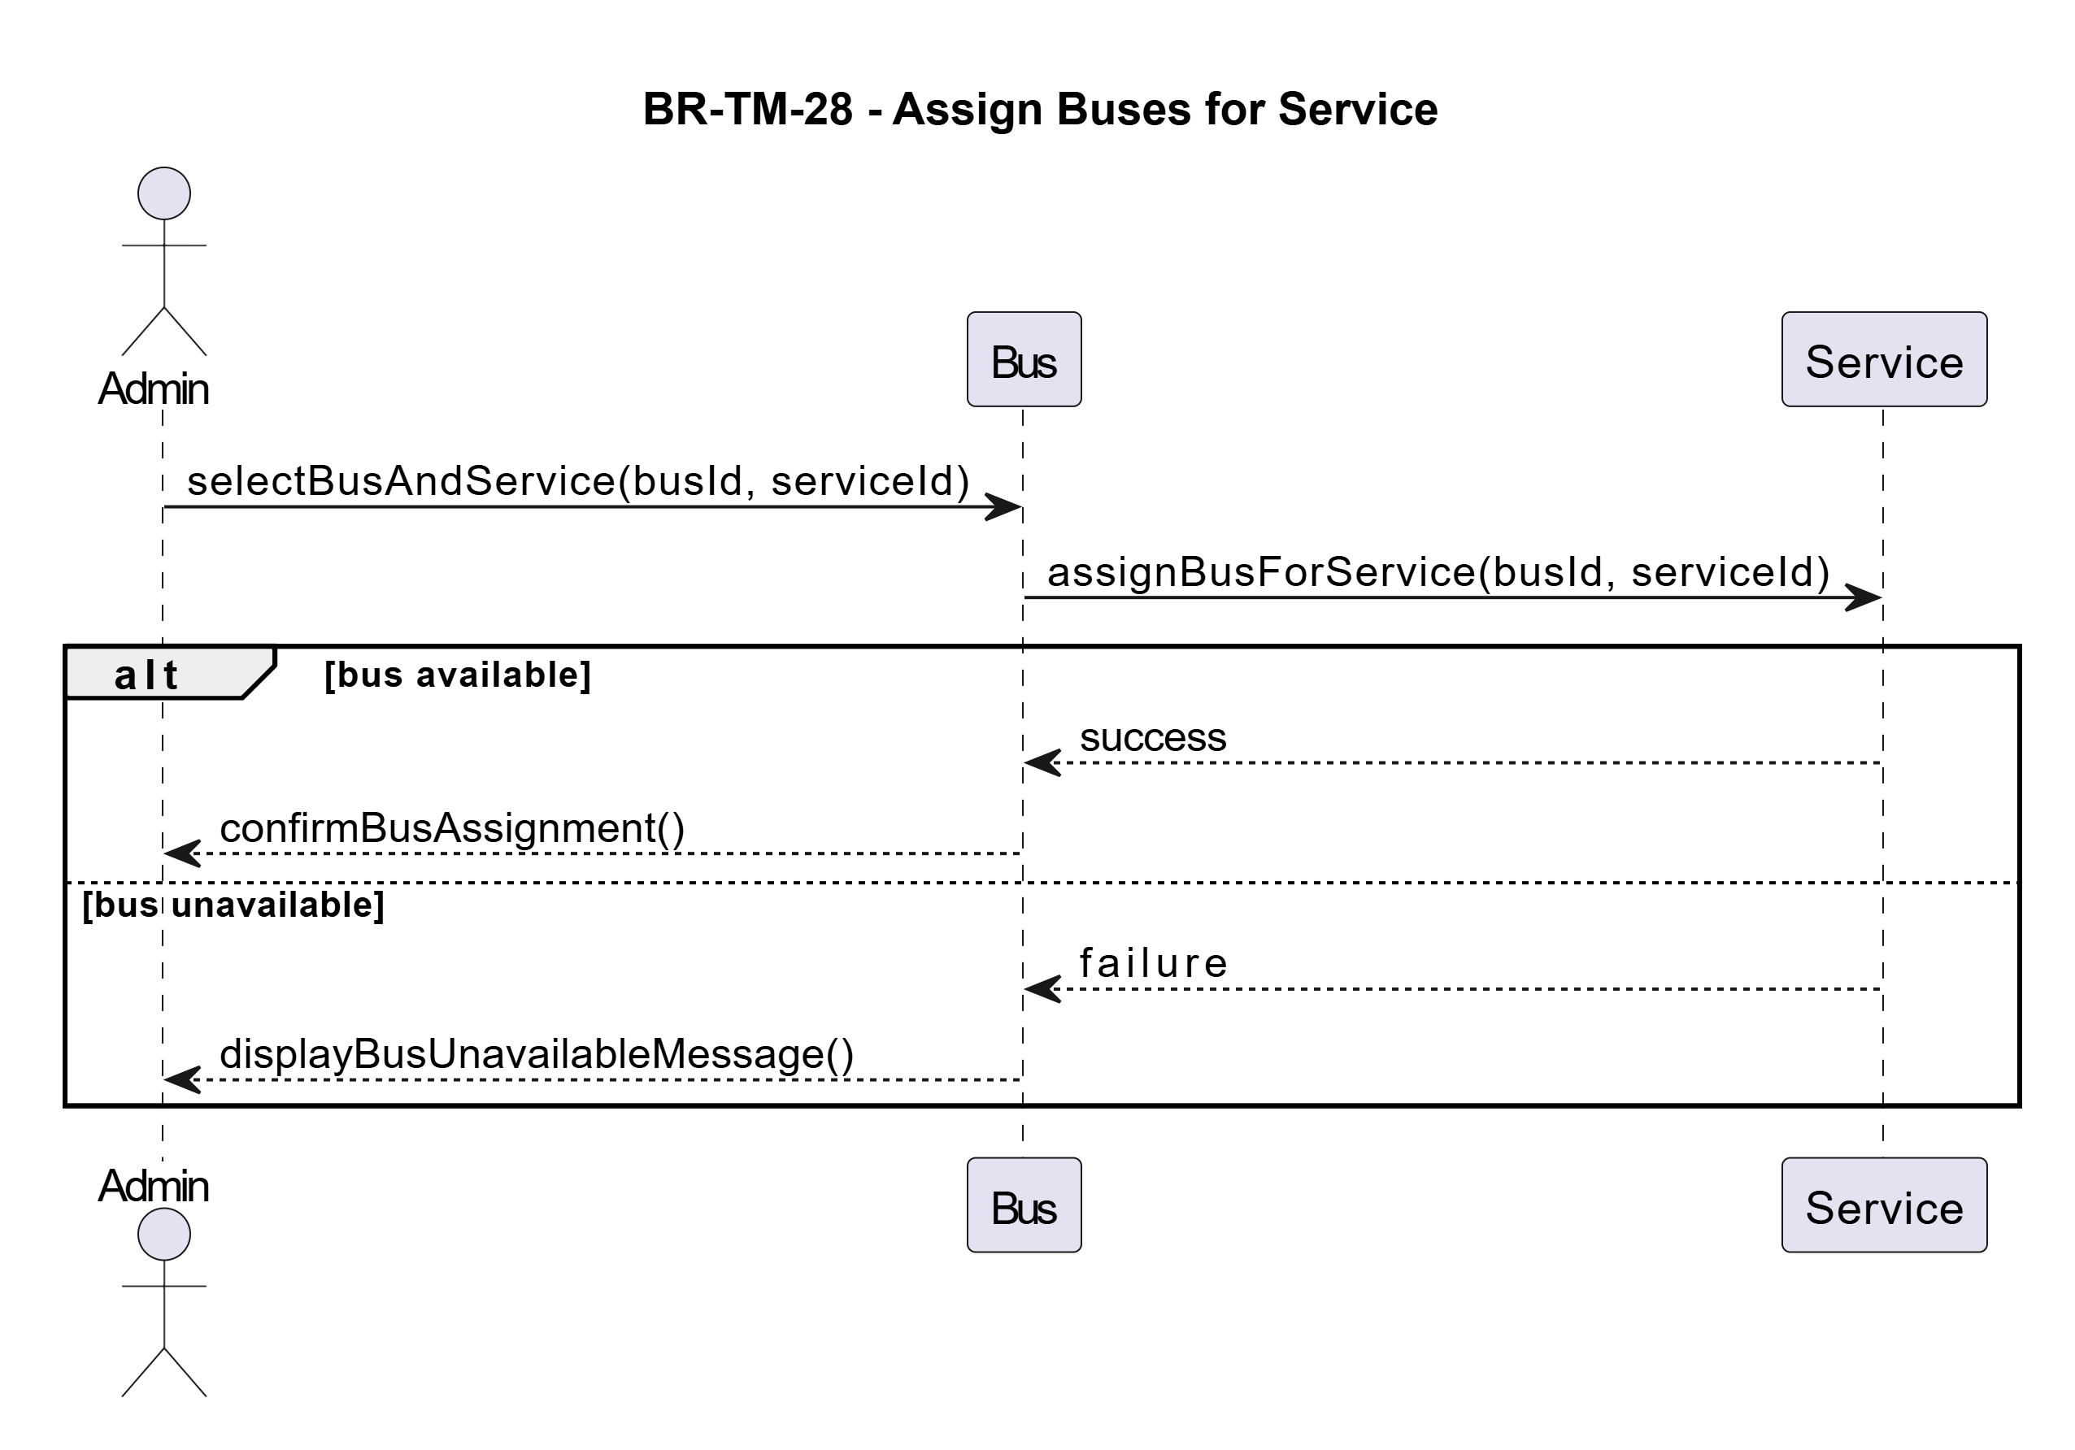

Era Selmanaj:
BR_TM_29 - Register number of buses
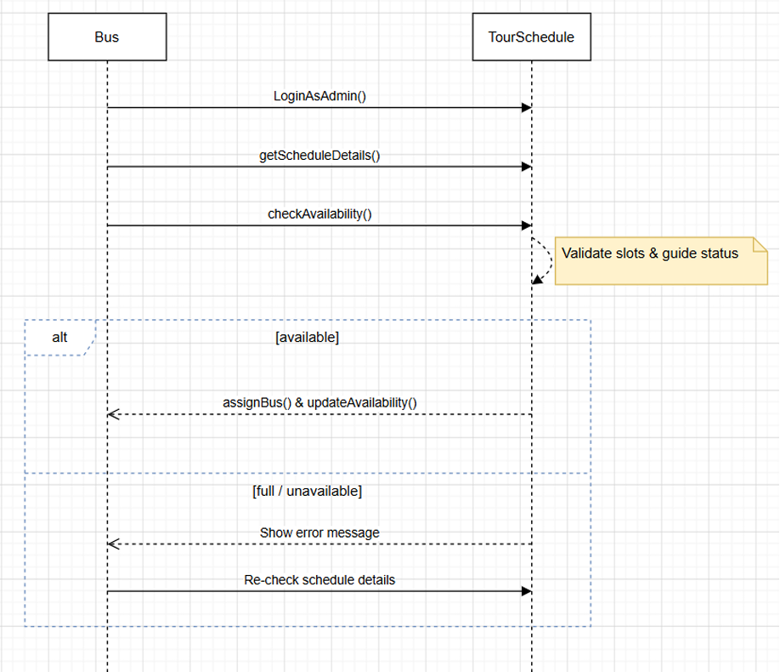
BR_TM_30 - Confirm Clients and Collect Payments
